Heart failure and polypharmacy

- Log in to NHS pathways (eclipse) - it is important to use this link as it takes you to the secure link which will ensure NHS numbers are shown for SystmOne practices in the excel download.

- Select Vista pathways 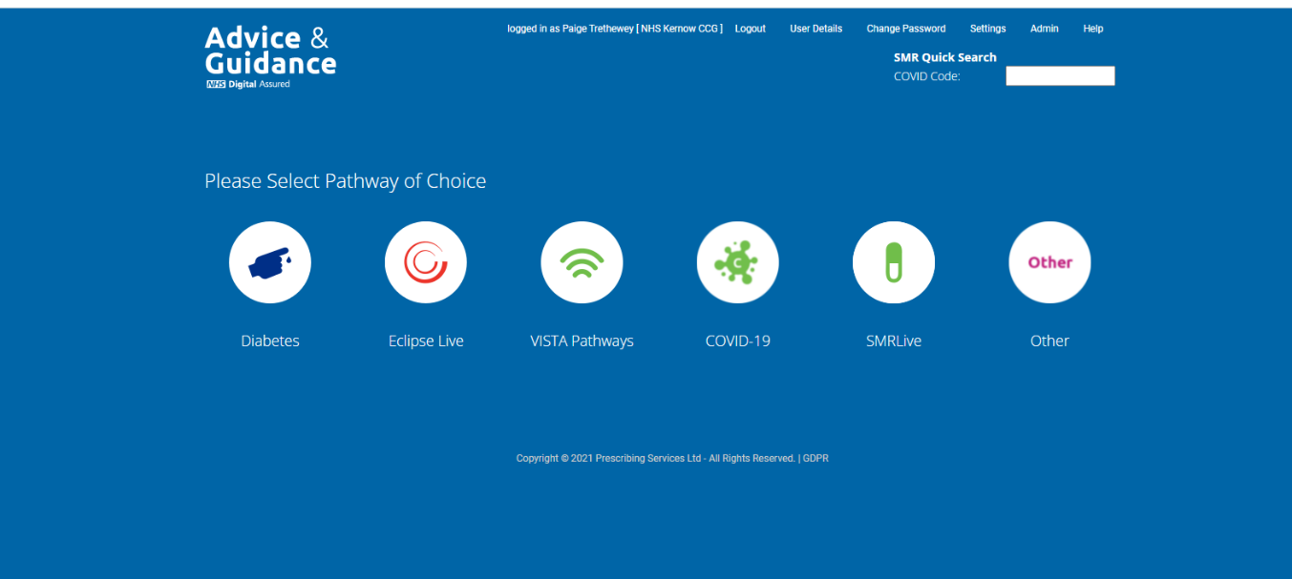

- Select ‘view’ on the heart failure pathway
- Select patients

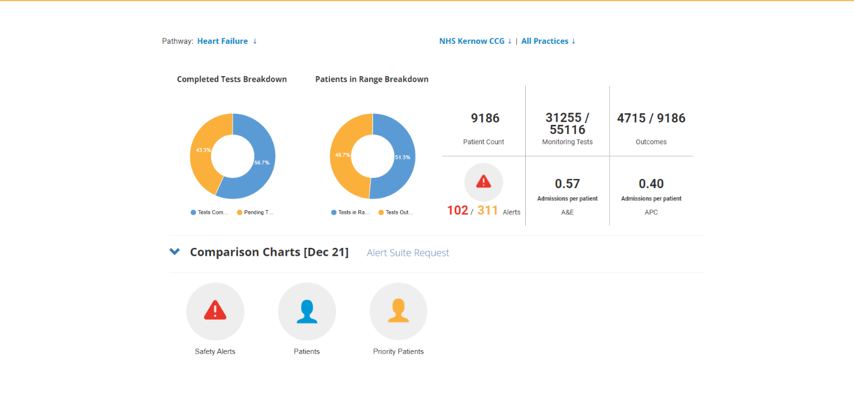

- A list of patients will be produced. By clicking on the ‘drugs’ header twice, you can sort from high to low to prioritise patients with highest number of medications prescribed.

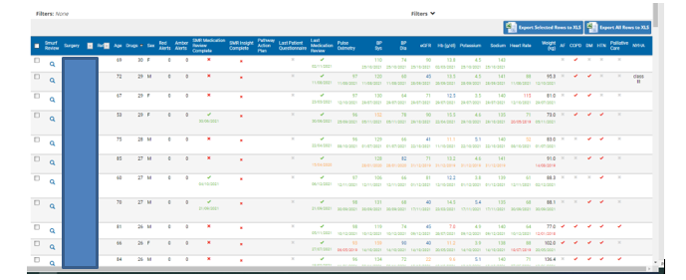

- Data can be exported to excel using the export button at the top right of the table, this will also include clinical parameters for the patient, however, as Eclipse is reviewing this function we would recommend only using Eclipse to establish the patient list, and using the GP clinical system to check clinical parameters and conduct the review.

- Occasionally, a patient may be included in the report who does not have heart failure. This is being reviewed but may be due to anomalies in historical coding. If you experience this or any other issue, please let us know so that we can work with the Eclipse team on this. The Eclipse team can also be contacted via the Help section (via chat box or telephone).

